Project Report

Face Feature Extraction

Name: Revanth Kalluri
Course: AI & ML (Batch-5)
Problem Statement: Apply Face Feature Extraction using PCA.

Prerequisites:
Software used and how I installed them:
Python 3.6: Download and install anaconda using https://www.anaconda.com/download/. After installing anaconda, install below modules(packages), using anaconda prompt to run the commands.
Module | Command
numpy | pip install numpy
sklearn | pip install scikit-learn
matplotlib | pip install matplotlib

Pip is a package manager for python packages. Run “pip --version” in anaconda prompt to verify if pip is already installed. Run “conda install pip” to install pip for the first time.

Dataset used:
The data source used is fetch_lfw_people from sklearn.datasets.

Method used:
Prinicpal Component Analysis.

1. Importing necessary modules:
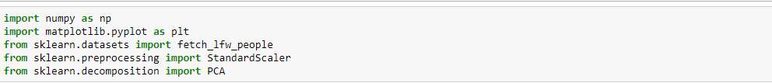
2. Read images and store it in required format:
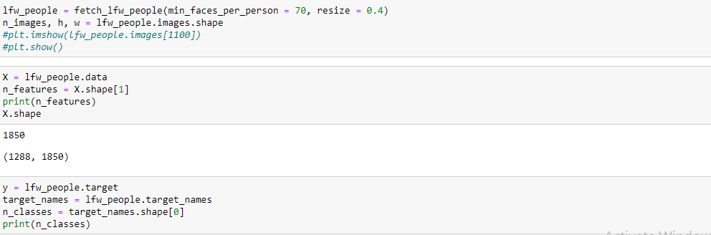
3. Normalize the image vector:
4. Apply PCA:
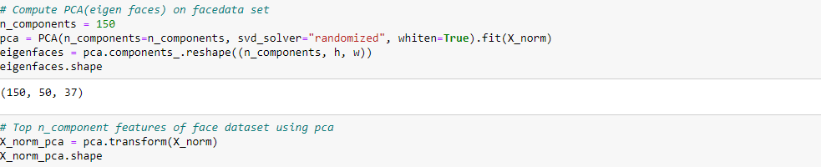

5. Plot Eigen faces:
